Unity in Diversity

During the 10th until 17th of November 2018 in Rajcza (a small town in the south of Poland) took place the international Youth Exchange within Erasmus+ “Open mind, open heart, open Europe” hosted by the Polish organization “We add wings”. This project reunited 41 young people from eight countries: Croatia, Estonia, Hungary, Italy, Lithuania, Poland, Portugal and Romania. The main scope of this exchange was to make young people more sensitive and aware of the social phenomena that are caused by ignorance, prejudice, discrimination, and are present in Europe and all over the world recently.

Over the one week exchange, participants learned how to be more acceptant of the differences between their countries and personalities and worked together towards realizing tasks, powerful movies and street campaigns. The preparations for the exchange took almost 3 months in which the hosts of the project, Agnieszka Zawislak and Basia Zachnik- Malok, communicated and prepared the paperwork with partners across the borders.

What surprised both the participants and the coordinators was the uniqueness of the people who got out of their comfort zones to take part in this project. “The group of the project was very divers. We had participants from different backgrounds, having different habits and traditions. Some of them had experience of taking part in youth exchanges, some of them not, but all of them put maximum engagement intro activities and tried their best to contribute to the project.” says Agnieszka.

### During the exchange, we had bonding activities such as hiking together a nearby mountain, visiting Bielsko-Biała, a city 40 kilometers away from Racjza, and a secret friend task in which we were encouraged to give small gifts and write words of encouragement for a random participant during the whole experience.

### 

### .

The most valued experience was the cultural evenings in which we had the chance to taste some of the traditional dishes of every country. Personally, I was most impressed with the Estonian black bread and kama, a mix of kefir and kama flour, what includes wheat, barley, oats, rye and sometimes peas. We delighted our friends with zacuscă, a Romanian traditional dish made with eggplants, tomatoes, pepper and onion. In addition, we had the pleasure of listening 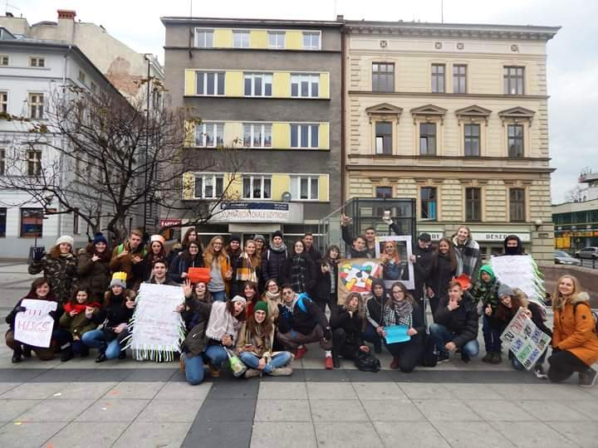traditional Polish music played by our very talented friends and danced together on Lithuanian rhythms.

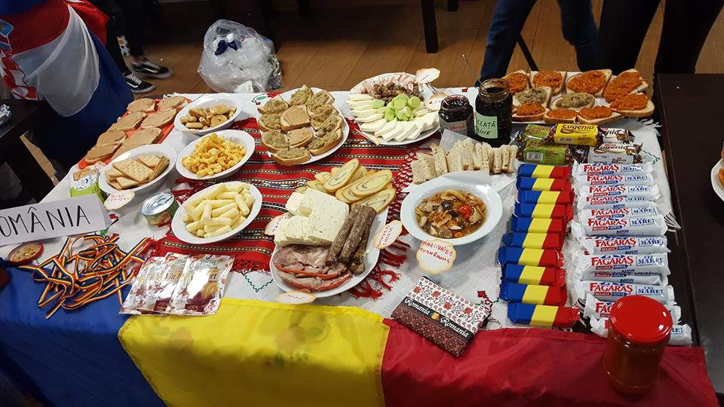

### One of the main challenges was the accomplishment of the street campaigns in Bielsko-Biała. From coming up with ideas and following the steps our guiders advised us to use, untill actully applying them in the city cener of Bielsko- Biała there were a lot of discutions and different perspectives that needed to be integrated so that no one felt that their ideas were not good enough.

### For Aga Pietraszko’s team the biggest challenge was that they ” needed a lot of specific information about homlessness and how they could help those people in need”. Their idea was that homless people are not bad people, but had unfortunate lifes and that we need to stop the stigma surounding this subject and actually do someting to make their existence easier. They manufactured some card on which was written the adress of places in which they could eat, rest, take a bath, get a little warm and someting to wear. This is just an example of the street campaings we implemented in Bielsko-Biała. We had another 3 teams which spread the good vibes and cultural diversity using other ideas such as free hugs and pictures with the hastag #spreadlove.

### Another important task was the creation of movies ”Be more…/ Be less” in which we encouraged people to be more tolerant and less illiberal.

For Sonja Roosson, a participant form Estonia, the most valuable lesson was “that although people come from different backgrounds- different cultures, traditions and have different values- and that you might not agree with them on everting, it is still very possible to find common ground and become close friends, if you treat their perspective with equal respect.”

In a kind, nurturing atmosphere in which the exchange of ideas was encouraged throughout discussions, debates and many other methods, the goal of the project was achieved and many of us, taking part in this project, came back home, with at least a slight change in our perspective, in our way of perceiving the world. This project helped to bring together a diversity of people, united by the same goal: to open their hearts, open their minds and in the end to open the gates of Europe.